**NFL Visualization: Discovering more about the teams.**

Taylor Moede, Zach Johnson Elias Ortiz

University of Colorado at Boulder

# ABSTRACT

We began looking data that would involve sports and looking at teams in a new unique way. We thought that it would be interesting to look at more aspects of the National Football League, or the NFL, instead of just how well a team performs. A lot of people only consider the wins and losses of a team but that is not always why people love a certain organization. If we look at the Cleveland Browns, their team doesn’t win much as of late but they still have a dedicated fan base. For starters we searched for different data sets that would allow us to visualize other aspects than just wins. We came across a fan who needed to find a new team to cheer for after the St. Louis Rams moved to Los Angeles. He took into account things like stadium experience, uniform deign, value of a ticket and much more in order to discover which teams are worth following. The interesting part about the attributes and scores of each team is that they can be looked at and weighed more by what a person sees more fit. If stadium experience means more to a user then that will be considered over something like uniform design and they can toss those scores aside. Adding up different attribute scores provides different results for top teams based on what is chosen.

**Keywords**: Attributes, Team, Scores.

# INTRODUCTION

This dataset was created by one NFL fan who was in search of a new team to support after his team, the St. Louis Rams, moved to Los Angeles and he felt betrayed. That being said, there is a large amount of bias in the dataset because it was created by only one NFL fan. Ideally, this dataset would be much more complete and sound had we been able to survey NFL fans of all teams and have a larger sample of data. The main motivations for this project were, as stated in the abstract, deciding which teams in the NFL are best to support and understanding why they are the best based on our own bias, helping people who do not have a favorite team make an educated decision on who to support based on the bias of the creator, and which teams would be best to go see if you are an NFL fan in general.

After viewing the dataset, which has sixteen attributes, we decided on five attributes that our group decided were most crucial to determining which team is the best to support. The five attributes were: Stadium Experience, Value of Ticket, Fan Relations, Tradition of Winning (Organizations history of winning championships, divisions, and wins overall), and Coaching. This is interesting because this shows the bias that was discussed above and the bias that we as a group have on the dataset. Being able to choose which attributes are most important to any individual changes the results of the top tier teams in one person’s opinion.

We still found it important and relevant to display all of the attributes that we were given, as well as displaying the ranking of all of the teams that the creator of the dataset provided. This

mattered to us because. This is interesting because it shows how different NFL fans have different biases towards aspects of teams.

This is even true for our group in general because the three of us all support different teams, the Broncos, Packers, and Seahawks.

Another thing we believed was important to display was the ability to compare teams based on single attributes, not just on the big picture of the whole dataset. If a person views say Coaching as the single most important attribute, you are able to compare which teams have the best coaching staff, in the biased opinion of the creator of the dataset.

# Map of All Teams (Star Rated)

The first visualization seen on our webpage is the map we have discussed. Showing the teams on a map is essential to our project because there are a surprising number of people that don’t truly conceptualize where a team is in the country. When an individual takes a look on the map of the closest teams near them, they will observe the star ratings. These star ratings allow the user to understand where a team falls under the five attributes we found most important. Those, for a reminder, are Coaching, Fan Relations, Ticket Value, Stadium Experience and Tradition of being a winning program. This portion of the project was primarily built with Leaflet and open source JavaScript library. We began with “[a] simple step-by-step guide that will quickly get you started with Leaflet basics, including setting up a Leaflet map (with Mapbox tiles) on your page, working with markers, polylines and popups, and dealing with events”(Leaflet). The click events enable the user to explore the map and examine one team at a time. This initial view gives them a small taste of the caliber of a team.

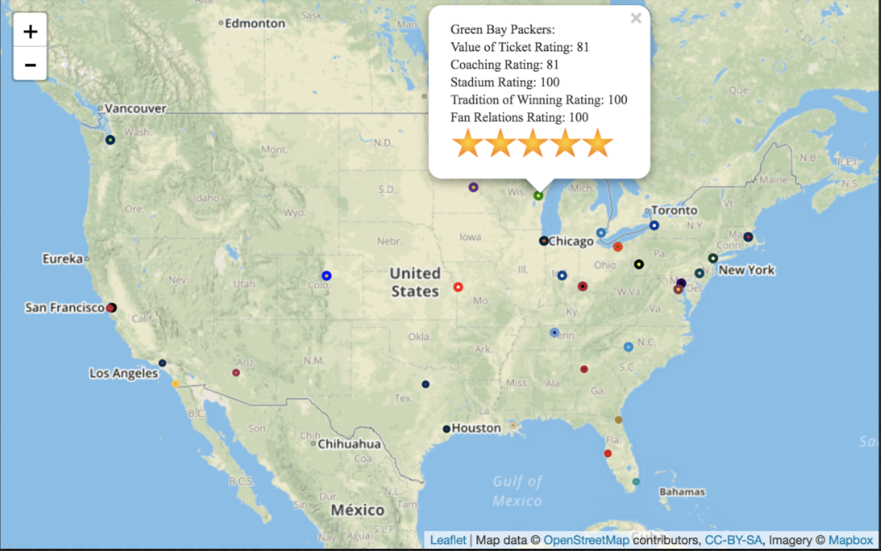

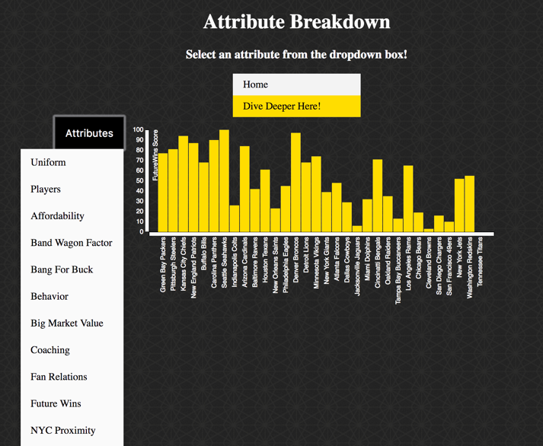

**Figure 1: Leaflet Map. Every point is an NFL team.**

## Hierarchical Bar Chart of Total Ratings

The second visualization that can be seen in our website can be seen below. This hierarchical bar chart shows each and every team with their aggregate scores ranked in order of most points to least. This is meant to be a more general digestion of the data being presented. A user can use this and see why each team is in their respective spot. Once a user clicks on a particular team, the graph will then reveal a detailed breakdown of every single attribute in the data used to rank that team. The User can then click on empty whitespace and it will take them back to the graph with all the teams. Being able to search a team’s strengths/weaknesses was valuable to us because then a user can come in with previous knowledge and already have a favorite NFL team but may not know why or how their team ranks up with the rest of the NFL in categories they might not have thought about before.

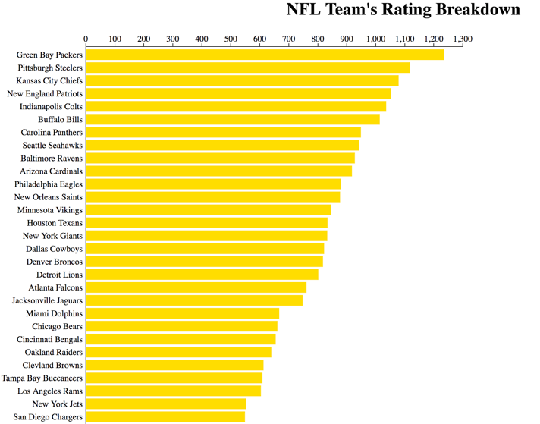What this visualization does fail to do, is give a person that doesn’t already have background knowledge of the sport to make an educated decision on what their favorite team should be. This exploratory bar chart was meant for someone to compare what they already know to something that they possibly have never thought of. They can also use it to deepen their understanding of their fandom over a certain team. The next visualization on our website does take care of that.

## Figure 2: Shows team rankings base on every attribute with a detailed breakdown shown on click

## Bar Charts of Attribute Scores

This visualization allows for more explanation of the previous visualization, the hierarchical map. This set of bar charts displays each of the individual attributes in the dataset and shows the score of each team in each attribute. This dives deeper than the previous visualization because the hierarchical bar chart only shows the comparison of the total score overall and the attributes of one team at a time. This made us think that we needed a better comparison and explanation tool to better describe and display our answers and motivations. If one attribute in the dataset is

# Figure 3: Displays bar charts for every attribute showing the scores for each team

more important to a user than another, then this visualization allows for a more precise and educated decision to be made about which team to support based on your own biases. We will discuss a study of our data visualizations in the discussion section. Figure 3 is a screenshot of the visualization that “dives deeper” and gives a better understanding of each attribute. This is a simple display of bar charts using the JavaScript library, D3 or Data-Driven Documents. A simple dropdown menu is shown in the figure as well to show how we switched from one attribute to the next.

# Experiment Discussion

To see if our dataset worked for our motivation of helping users find a team, we asked a friend, who is not affiliated with any team, to look at all our visualizations and find a team to support. Andrew, our subject, is from Las Vegas, Nevada so he decided to look at teams in relative proximity to his home. These teams were: Arizona Cardinals, Los Angeles Rams, San Diego Chargers, San Francisco 49ers, and Oakland Raiders. He then chose the three attributes most important to him, Stadium Experience, Affordability, and Future Wins, as well as the cumulative score of all attributes from the hierarchical bar chart. Taking all of this into account, the Arizona Cardinals were his team of choice, based on his bias, because they outscored all other teams in every category and they are closest in proximity to Las Vegas.

After choosing his team, Andrew said, “Taking into account my own biases and where I am from, these visualizations and scores make it simple to choose a team to support.”

# CONCLUSION

While most people only take into account wins and losses as a measure of their favorite NFL teams, this set of visualizations show a completely different way of analyzing teams. With the first visualization being a powerful visual tool, the user of this website can not only see where every single team is located around the country, but they can also see what team is closest to what they consider home. Having a home team is something that happens to be very important, as people tend to have an emotional attachment to these teams. As mentioned before, most people haven’t fully thought about where these teams are located and that may shed some new knowledge even to those veteran NFL fans. A common theme that is shared between the first two visualizations is that a person with background knowledge in the sport can still use them and learn about their favorite team, or the NFL as a whole, no matter how much they think they already know. They might have a intuition as to why their team is good and how their culture compares to another teams but here they can see hard evidence on why each team excels in what attribute of data.

The third visualization, arguably the most educational, is most valuable to people that have not formed passed biases over the sport. A user with a fresh mind, that not necessarily knows the game all that well, can still pick out a favorite team by comparing every single team at the same time based on attributes they think is most valuable. They can tailor their experience with this visualization to what they care about the most and make a more educated decision on what their favorite team should be.

In the grand scheme of things, these visualizations show that there are a multitude of ways of ranking a team. Things as visual as uniform design can help persuade someone to root for that team. The marketing strategy of a team can also show the dedication the management of the team has to grow the franchise. For a real fan all of these other attributes matter. Wins and loses sure do help in determining what team is good and bad, but not everything is what meets the eye.

# REFERENCES

1. "Tutorials - Leaflet - a JavaScript Library for Interactive Maps." *Leaflet*. N.p., n.d. Web. 07 May 2017.
2. W3schools – All HTML help came from here
3. bl.ocks.org – All D3 help came from here
4. Andrew Callahan – Experiment Subject